AMY1A no dama restricted library

<http://www.lcqb.upmc.fr/myclade/results.php?form=large&job_id=T5A4G4nkGQw_20210405>

AMY1A no dama

<http://www.lcqb.upmc.fr/myclade/architecture.php?form=large&job_id=A4pBE9yuQw7_20210405&id=trQ6NSB3Q6NSB3HUMAN>

<http://www.lcqb.upmc.fr/myclade/architecture.php?form=large&job_id=mYxOs86MOzw_20210405&id=trQ6NSB3Q6NSB3HUMAN>

<http://www.lcqb.upmc.fr/myclade/architecture.php?form=large&job_id=it17uceagyG_20210405&id=trQ6NSB3Q6NSB3HUMAN>

SPASM DAMA

<http://www.lcqb.upmc.fr/myclade/results.php?form=large&job_id=OvHJn84CYeA_20210405>

<http://www.lcqb.upmc.fr/myclade/results.php?form=large&job_id=I4w9YA89qoe_20210405>

**With DAMA:**

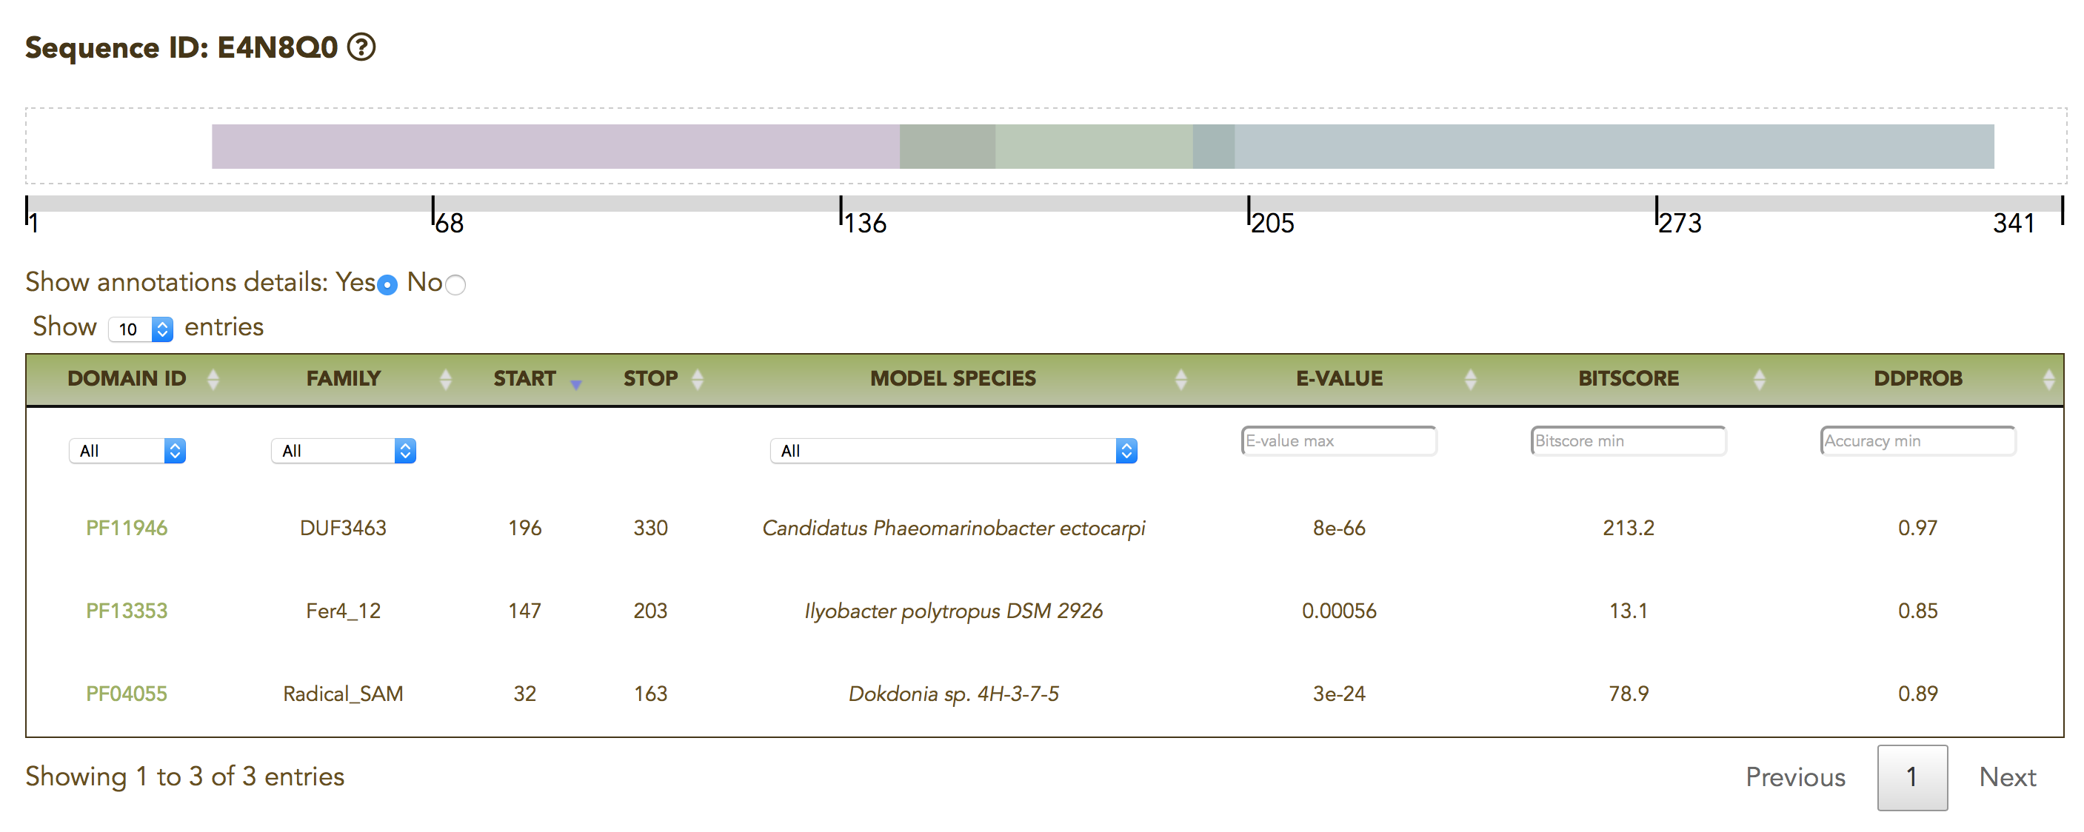

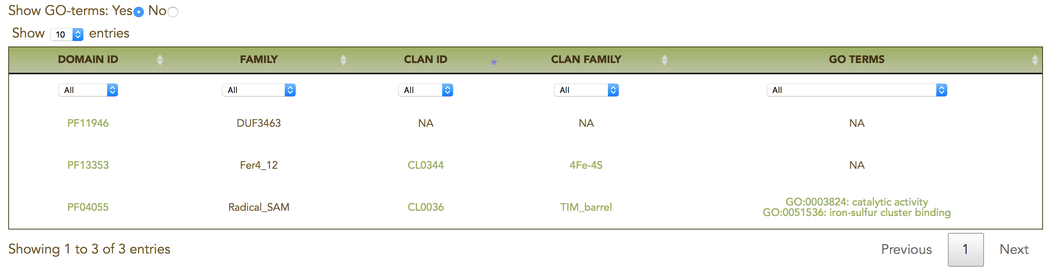

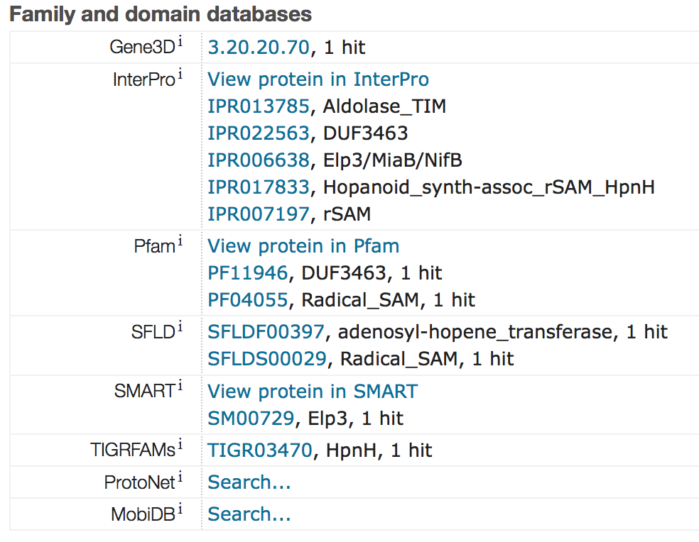

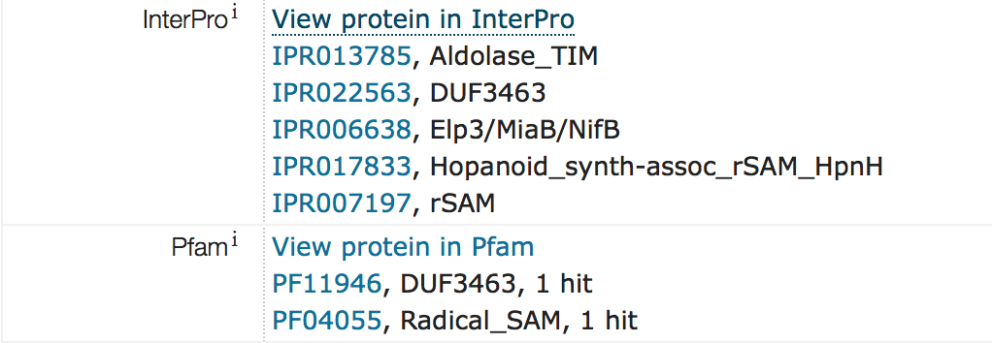

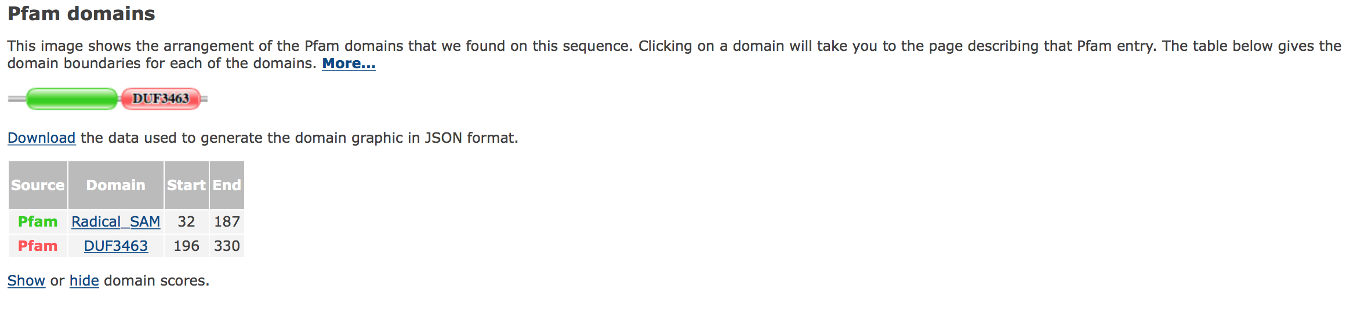

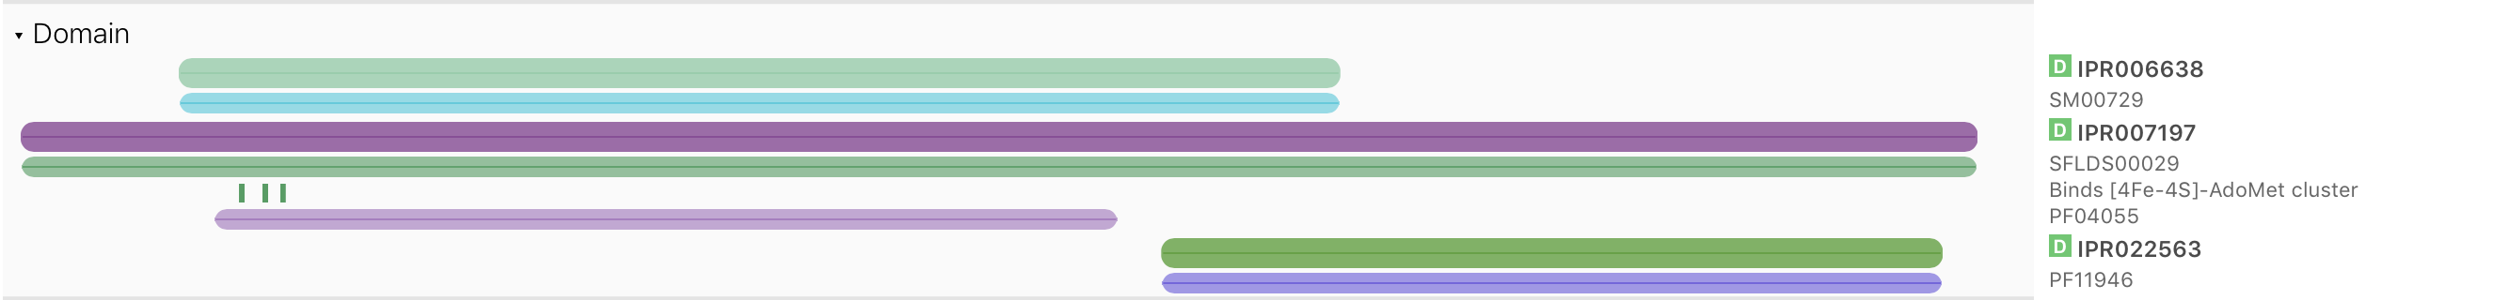

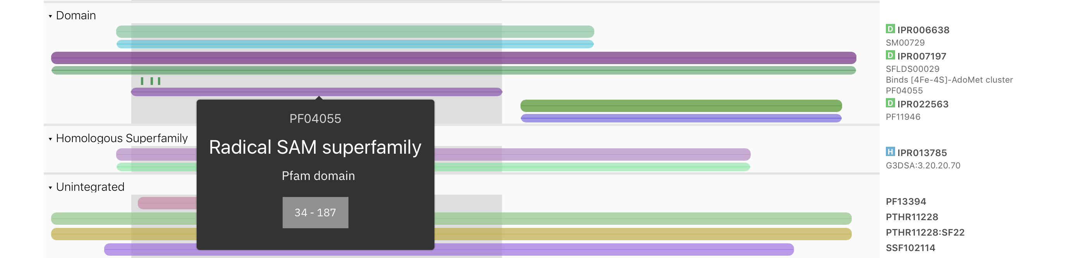

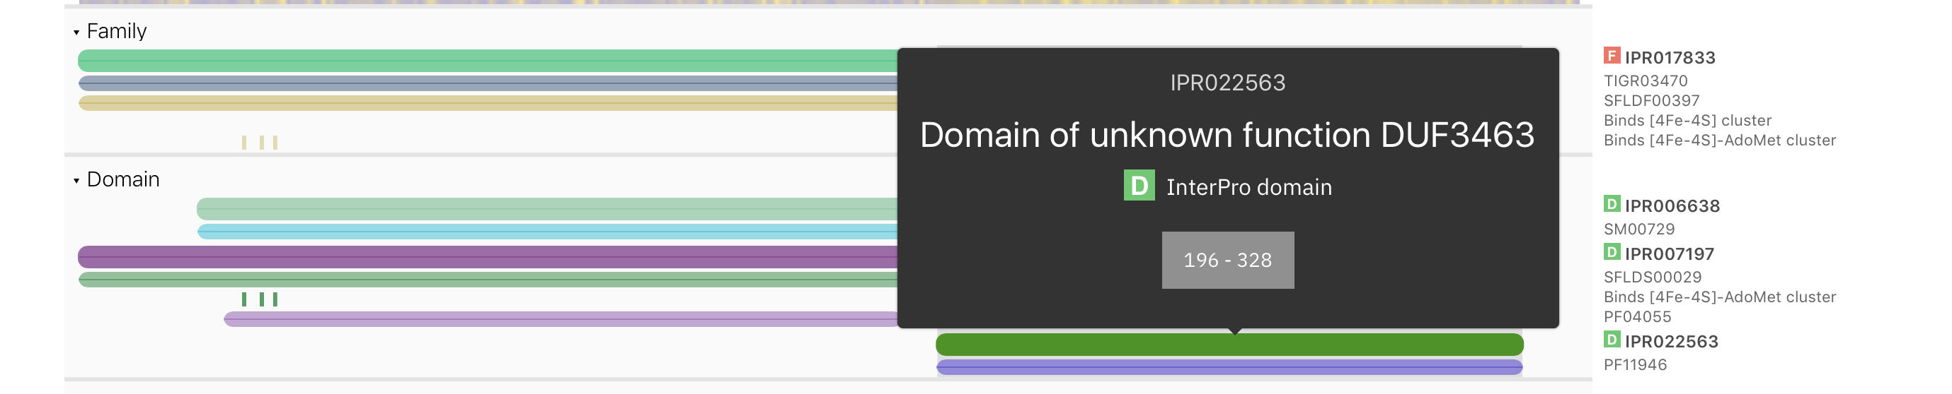

**With no DAMA:**

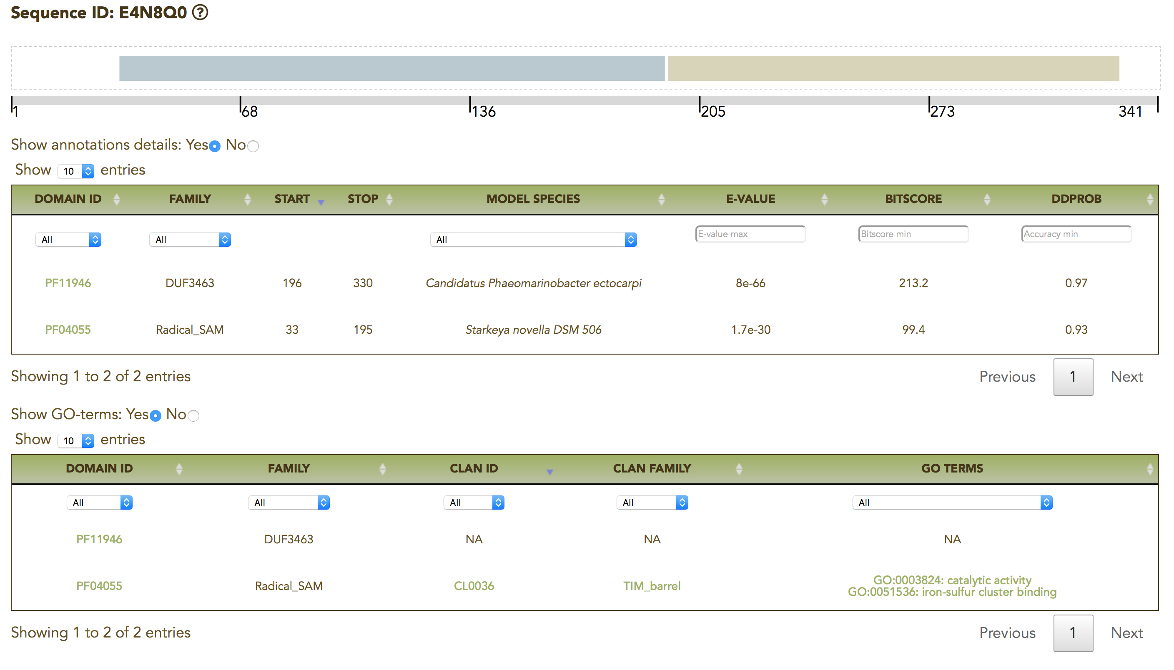

MEFV

<http://www.lcqb.upmc.fr/myclade/architecture.php?form=large&job_id=aMp0fOh56NK_20210405&id=spO15553MEFVHUMAN>

<http://www.lcqb.upmc.fr/myclade/architecture.php?form=large&job_id=kBewwcR46v3_20210405&id=spO15553MEFVHUMAN>